Balderton Surgery

**GP Newsletter**

May 2024

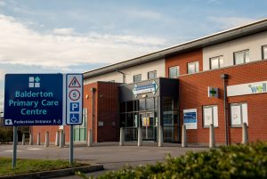**Welcome to our brand new GP Newsletter for Balderton Surgery**

**Birth month/Annual review’s**

If you have a chronic long term condition you need to have a yearly check up with the Practice nurse. We are aiming to get all of your reviews in line with your birth months. We will be in contact the month before your birthday to get these appointments booked. If for any reason you have not heard from us at the start of your birth month please call our Reception team to arrange these reviews.

The purpose of these reviews are to ensure you are taking the right medicaton and that your condition is being managed.

Appointments.

**How can we get an Appointment?**

Our telephone lines and the surgery doors open at 8.00am. You can come into the surgery or call our Reception team on 01636 705826 to make an appointment, Alternatively you can use our DR. IQ app.

**Appointment option’s.**

We like to give our patients the choice - if they would like to have a telephone call or to see a GP face to face, Our Reception staff can book either appointment to suit the individual patient. We do offer same day urgent appointments and prebookable appointment around 2-3 weeks ahead

**Can I ask to see the same GP?**

Of course! Our GP’s love to follow up their patients and our team have worked hard to design a rota that allows GP’s to book their own follow up’s whilst you are in the room with them. This will be booked if the GP feels they need to see you again.

**How long do I get to discuss my issues with a GP?**

Standard telephone or face to face appointments are 10 or 15 minutes. If you have a complex issue or feel you need more time with a GP please ask a member of our Reception team as we do offer 20 Minute complex appointments when requested.

**Can I ask to see a female GP?**

Yes absolutely. We have male GP’s and a Female GP. Dr Asante has recently joined us at Balderton and will be a regular GP here at the surgery.

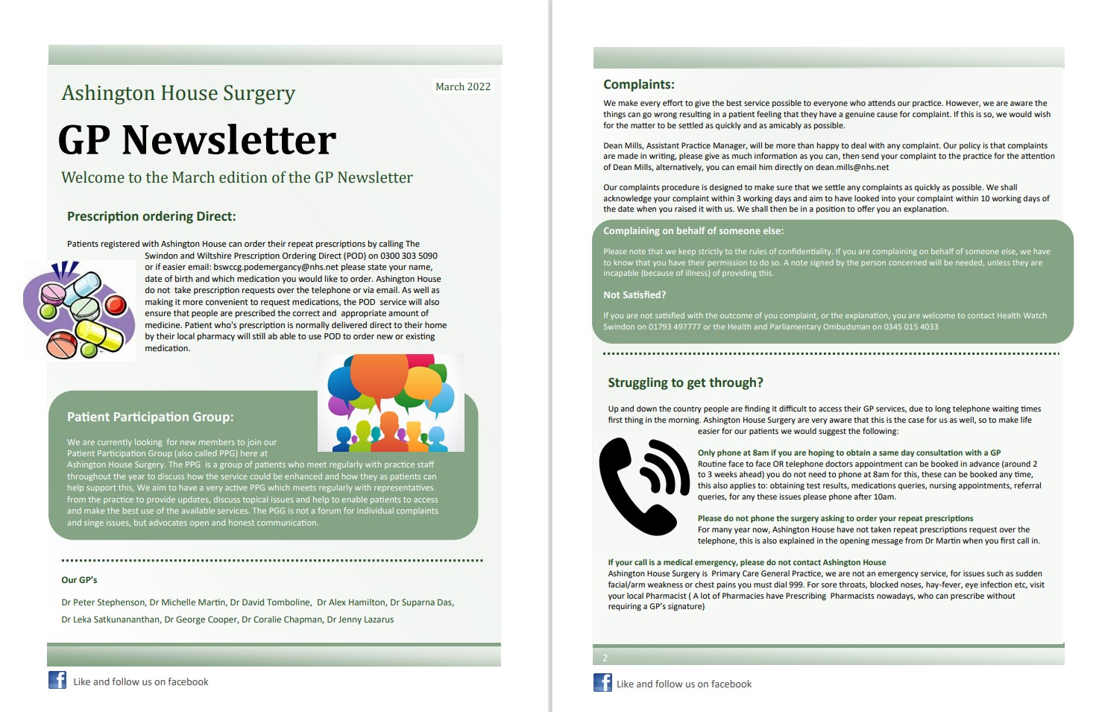

**Struggling to get through?**

Up and down the country people are finding it difficult to access their GP services, due to the long telephone waiting times in the morning. At Balderton Surgery we are aware that this is sometimes the case, so to make life easier for our patients we would suggest the following:

**Only phone at 8am if you are hoping to obtain a same day consultation with a GP**

If there is a long waiting time there is now an option to use our new call back system, this will keep your place in the queue and a member of our Reception team will call you back. Please note this does not guarantee you an appointment the same day as we may already be at safe capacity.

Routine telephone appointments or face to face appintments can be booked in advance (around 2-3 weeks ahead) you do not need to phone at 8am for this, these can be booked anytime. This also applies to obtaining test results, medication queries and nursing appointments. For any of these issues please phone after 10am.

**Please do not phone the surgery to order medication**

For a while now Balderton Surgery have not taken repeat prescriptons over the telephone. Please either order your medication online or pop into the surgery and ask a member of our Reception team who will be happy to help you.

**Option 6**

You can now press option 6 to leave a voice message to cancel your appointment to save you waiting on the phone line.



Why do receptionists ask such personal questions?

Receptionists are a vital part of the practice team. Their questions are to ensure that you are seen by the right

clinical staff member at the right time, and all information provided is kept confidential.



Thank you to all of our patients who have been completing the NHS friends and Family feedback forms. These forms are found in our clinical rooms and in the Reception area. If you wish to complete one we would appreciate this. – Any feedback is shared with our Reception team and in our clinical meetings.

**Pharmacy First**

From the 31st January 2024 Pharmacies in Newark and Balderton are taking part in the pharmacy first service.

Pharmacists can provide advice and NHS-funded treatment (e.g antibiotics), where clinically appropriate for the seven conditions below:-

Infected insect Bites

1 Year old and over

Sinusitis

12 years old and over

Shingles

18 years and over

Sore Troat

5 Years old and over

Ear pain

1-17 years old

Urinary Tract Infection

Women 16-64 years old

Impetigo

1 Year old and over

Our brilliant team at Balderton Surgery consist’s of

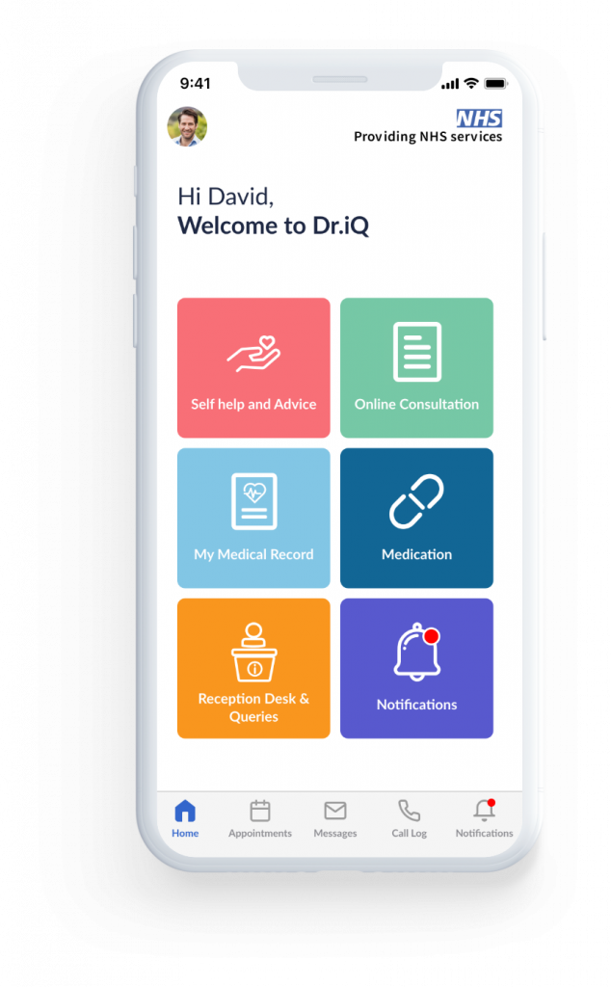

Christine Clark – Practice Manager

Abbey Shalloe – Reception Team Leader

**Clincal Team**

Dr O Oke – Regional Medical Director/ GP

Dr D Asante – Lead GP (Female GP)

Dr T Joy – GP (Male GP)

Dr A Patel – GP (Male GP)

Dr E Udeze – GP (Male GP)

Loretta – Clinical Prescribing Pharmacist

Melissa – Advanced Nurse Practitioner

Chrissie – Lead Practice Nurse

Jade– Practice Nurse

Paula – Health Care Assistant

Sravani – Health Care Assistant

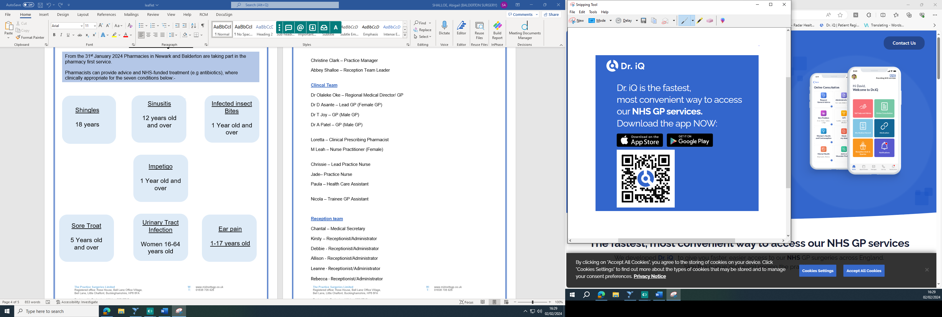Nicola – Trainee GP Assistant

Laura – Physiotherapist

**Reception team**

Chantal – Medical Secretary

Kirsty – Receptionist/Administrator

Debbie - Receptionist/Administrator

Allison - Receptionist/Administrator

Leanne - Receptionist/Administrator

Rebecca - Receptionist/Administrator